How to Password Protect MS Word 2007 document
Article Source: http://recoverlostpassword.com/article/password-protect-ms-word-2007.html

If your Word document contains sensitive information, it is necessary to be set with a special password. You can password protect your Word 2007 document to keep them safe and secure from unauthorized access. This article covers how to set a password to a MS Word 2007 document so that a password is required to view or modify it.

How to Password Protect Word 2007 Document Containing Sensitive Information?

Step 1: Click the Microsoft Office file Button, and then click Save As. Save your document as a Word document or Word template.
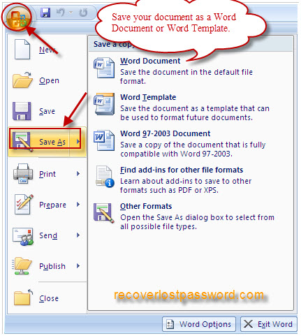
Step 2: When “Save As” window pop up, Click Tools, and then click General Options.
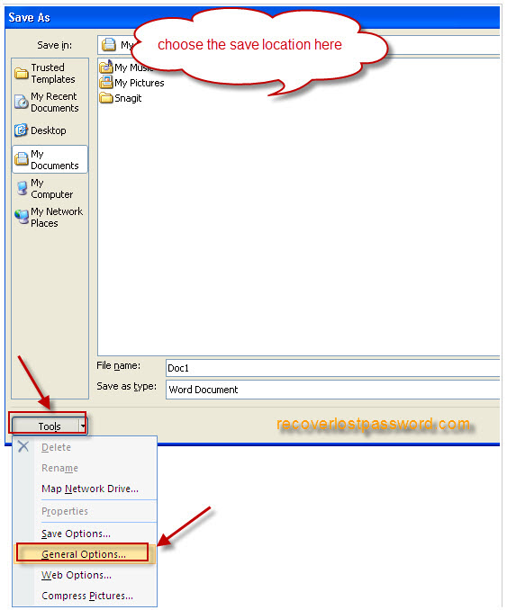
Step 3: You can type a password in Password to open or Password to modify or both of them. Click OK.
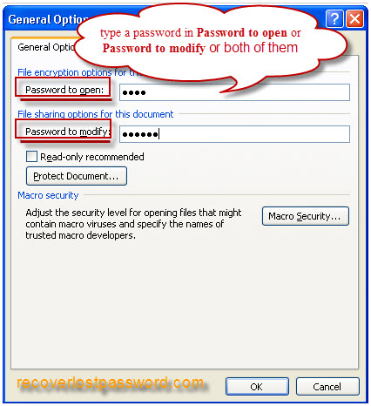
Step 4: When Confirm Password prompted, retype your passwords to confirm them, and click OK.
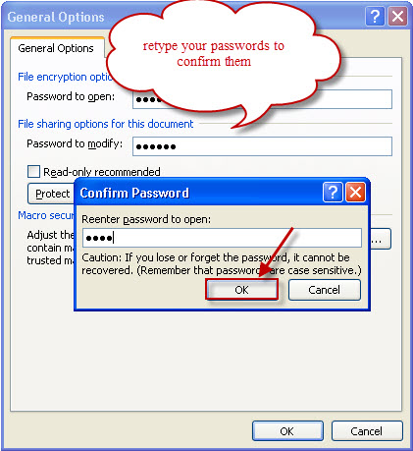
Step 5: Select a save location, type in a filename, and then Click Save.
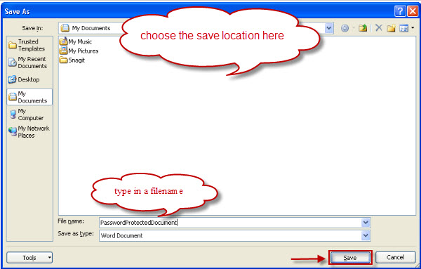
That’s all, how easy it is! Then the next time you open your Word 2007 document, you’ll first be prompted to type the password to open the document. So, do not forget the password, or only Word Password Recovery tool can help you crack the password.

TIPS:

All the original articles are authorized by SmartKey, welcome To Transshipment but Please Retain the original.
If you are interesting in Word Password Recovery, please visit our website.

